**XHTML & CSS Tutorials**

# XHTML and CSS Tutorial - 1 - Downloading a Text Editor

<http://www.youtube.com/watch?v=cqszz_OfAFQ&feature=edu&list=PLC1322B5A0180C946>

Type in the Notepad++

<!doctype html>

<html>

<head>

<title> This is the title </title>

</head>

</html>

Save it as ***index.html***

Name your file: index – this is pretty much the main page for the browser

It opens the webpage with the title we mentioned.

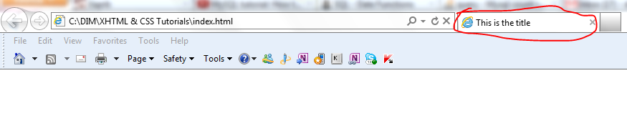

Inside of **<html>** tag we have **<head>** and **<body>** tags.

The <head> tag contains technical information, key words, the name of the page, etc.

The <body> tag contains all the visual info

We have a “beginning” and “ending tags” for every tag we put.

Ending tag has a forward slash “/”

For example: <body> xxxx </body>

Everything that goes between those tags will be considered as a body

# XHTML and CSS Tutorial - 3 - body and headers

Header tag. There are 6 sizes. 1 is the biggest

<h1> Hello </h1>

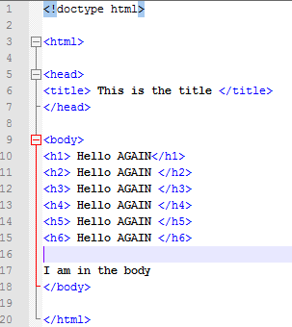

# XHTML and CSS Tutorial - 4 - Paragraphs and Line Breaks

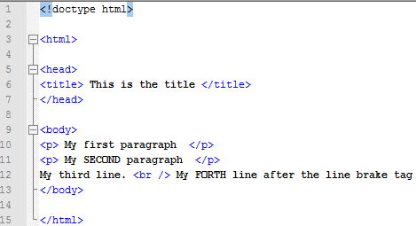

# XHTML and CSS Tutorial - 5 - Bold, Italics, and Comments

* <hr /> - makes a horizontal line across the website (stands for “horizontal rule”)
* <strong> </strong> -- to make it **bold**
* <em> </em> -- to make it *italic* (em stands for emphasis)

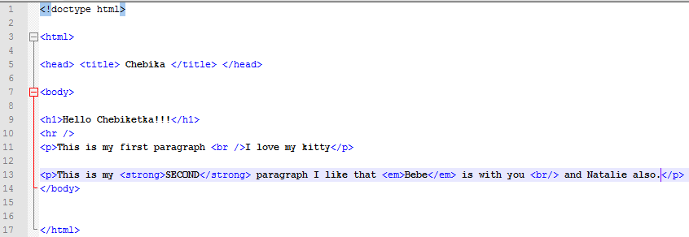

Comments

<!-- This is my comment-->

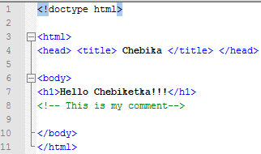

# 06. XHTML and CSS Tutorial - 6 - Adding Links to our Webpage

**Linking to the website**

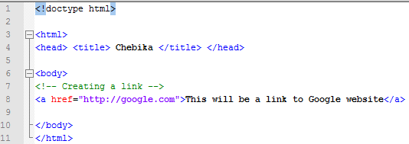

<a href="http://google.com">This will be a link to Google website</a>

<a> -- means anchor – a link to smth (href stands for hyperlink reference)

**Linking to another page**

(1) create another page

(2) save it in the same directory

(3) provide a link to that page

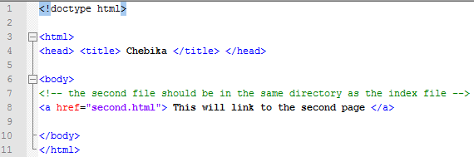

# 7. XHTML and CSS Tutorial - 7 - Creating a Link Within a Web Page

Using <a> <a/> tags create a destination

**Creating a destination mark on your website that will have a name “background”**

**<h2>** <a name="background"> </a> Recommended Background **</h2>**

Let’s say on top of our page we would like to create a link that will bring us somewhere in the same page. In our case to the section Recommended background. Again we a creating an anchoring links but instead of putting the name of another page we put the name of the anchor we just created after the # sign.

**href=#”background”** – don’t forget the # sign. It tells the browser that we are linking the same page no to another page.

**<a href="#background"> The link to the "Recommended Background" section on THIS page</a>**

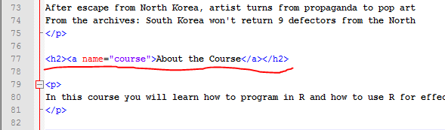

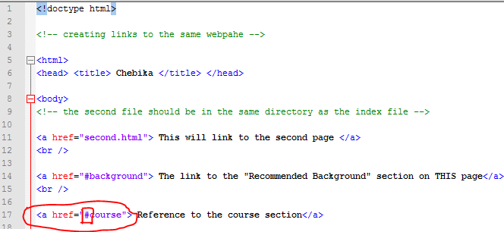

# 8. XHTML and CSS Tutorial - 8 - Email Links and Tool Tips

<a href="**mailto:** Natalia.Vakhrusheva@gmail.com"> email to Natalie</a>

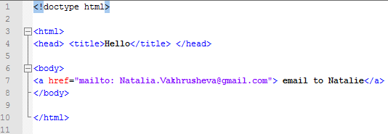

# Tool Tips

That is small comments that pop up on the screen when you point a mouse to that link

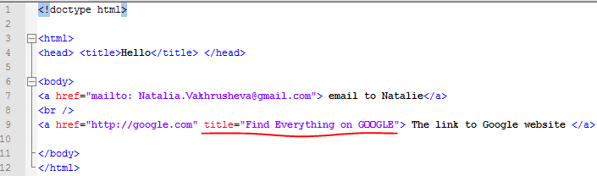

# 9. XHTML and CSS Tutorial - 9 - Adding Images to the Webpage

**Copy the image to the same folder where the html file is.**

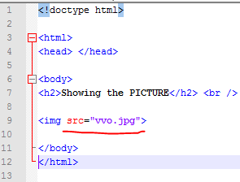

To make it as a clickable link add anchor tags to the image tag



# 10. XHTML and CSS Tutorial - 10 - Resizing Images

<img src="vvo.jpg" height="150"/>

However, in this way we do not decrease the “weight” of the image. The browser will still upload the whole big image and then shrink it to the size you mention in the “height” command. In order to decrease the real size we need first to use an editor (e.g. Photoshop).

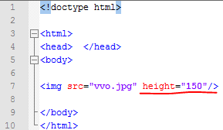

# 11. XHTML and CSS Tutorial - 11 - Tables

<table border="3"> -- assign the thickness of the border

<tr> </tr> -- tr stands for table row

<td> </td> -- stands for “table data”. Goes after the table row

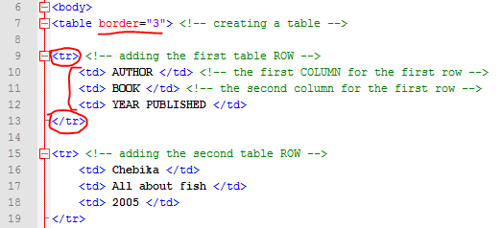

# 12. XHTML and CSS Tutorial - 12 - Table Headers and Movie Stars!

<th>Name</th>

Stands for “table header” – bold and centered

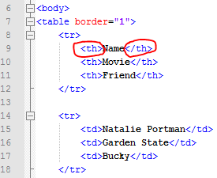

# 13. XHTML and CSS Tutorial - 13 - colspan & Annoying People

<tr>

<th colspan="2"> **<h3>** Odd People **</h3>** </th>

</tr>

To span 2 or more columns with one header we need to use the “colspan” command.

We can also add “header” tags to what goes in between table header tags.

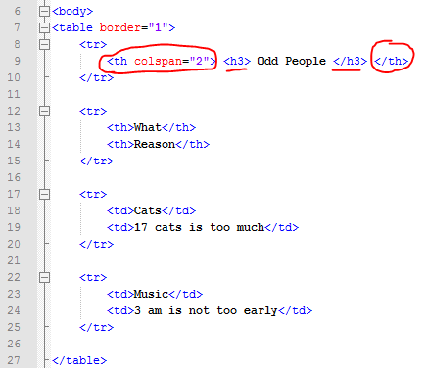

# 14. XHTML and CSS Tutorial - 14 - Table width, cellpadding, and cellspacing

**(1) Width (FIXED)**

<table border="1" width = "700">

We can assign the fixed number of pixels (width) to the table. It won’t change dynamically when we shrink the window.



**(2) Width (%)**

<table border="1" width = "100%">

We can assign the %. In this case it will change dynamically.



**(3) Cellpadding**

<table border="1" cellpadding="10">

Increase the space between the text inside of a cell and borders around.





**(4) Cellspacing**

<table border="1" cellspacing="20">

Provide more space between cells.



# 15. XHTML and CSS Tutorial - 15 - Lists

**(1) Unordered list**

<ul> <!--unordered list -->

<li> Computer </li> <!-- list item -->

<li> New Year Tree </li>

<li> Vacation </li>

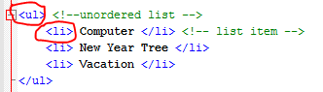

**(2) Ordered list**

<ol> <!--Ordered list -->

<li> Computer </li> <!-- list item -->

<li> New Year Tree </li>

<li> Vacation </li>

</ol>

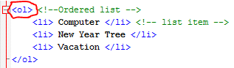

# 16. XHTML and CSS Tutorial - 16 - Intro to CSS

With XHTML you can build BASIC BLOCKS on the web page.

**CSS** makes it pretty (cascading style sheet)

We have to put in the head:

<style type="text/css">

And then define what and how we would like it to change:

For example:

For all paragraphs we want the color to be blue and font to be arial.

p {color:blue; font-family:arial;}

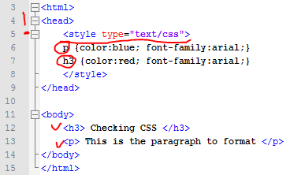

# 17. XHTML and CSS Tutorial - 17 - RGB Color and Line Spacing

In the CSS color we can use names for colors such as “red” or “blue”

Or we use RGB numbers.

We can use PhotoShop or this Website: <http://www.web-source.net/216_color_chart.htm>

To pick up some color codes.

Or go to Excel -- > Theme color to color the cell -->choose custom colors. Write down numbers for R,G, and B. Then go to the online RGB-to-HEX converter and get HEX number for the color.

<http://www.yellowpipe.com/yis/tools/hex-to-rgb/color-converter.php>

By default the space between lines in the paragraph is 1 or 100%.

<head>

<style type="text/css">

h1 {color:#F59DA7;}

p {line-height:130%;}

</style>

</head>

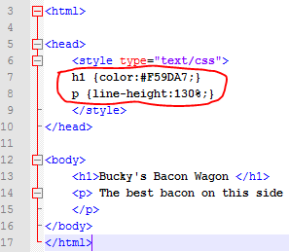

# 18. XHTML and CSS Tutorial - 18 - font-weight & font-style

Making text bold and italic with CSS

<style type="text/css">

ul {font-weight:bold;}

ol {font-style:italic;}

</style>

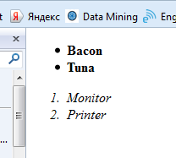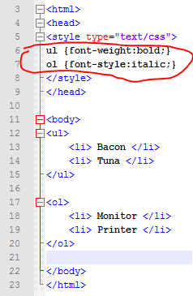

# 19. XHTML and CSS Tutorial - 19 - text-align and Changing Background Color

We can change the color of the whole “BODY”.

And also center the text

And indent the text.

<style type="text/css">

body {background-color: blue; color: white;}

h3 {text-align:center;}

p {text-indent:25px;}

</style>

</head>

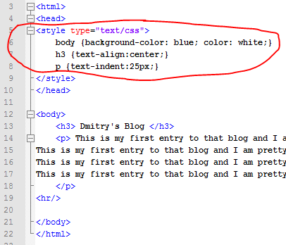

# 20. XHTML and CSS Tutorial - 20 - Background Images

That will multiply the image left to right and up to down across the whole page (for all pages as we implement it to the body).

body{background-image: url(dim_resized.jpg);}

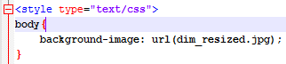

**If you do not want to repeat the image across the site:**

background-image: url(dim_resized.jpg);

background-repeat:no-repeat;

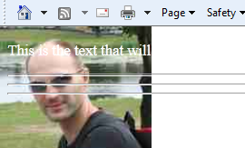

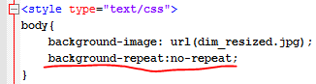

background-repeat:repeat-x;

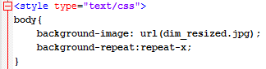

background-repeat:repeat-y;

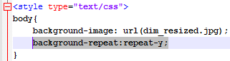

Shifting an image from the border.

10px -- 10 pixels from the left border

60px -- 60 pixels from the top border

background-position: 10px 60px;

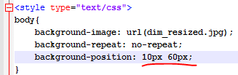

To center it from the left:

background-position: 50% 60px;

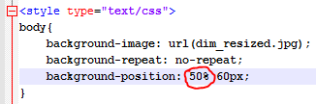

# 21. XHTML and CSS Tutorial - 21 - Padding

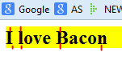

Padding is the space between the end of the letter and the border of yellow color.

<head>

<style type="text/css">

h2 {background-color: yellow; padding: 20px}

</style>

</head>

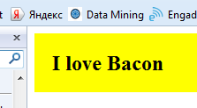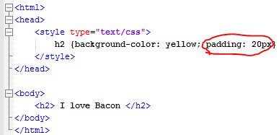

We add a pad between the text and the edge of our border with the size of 20 pixels. Around: Left, Right, Up, Down.

When you need to locate your items very specifically on the screen.

In order to change padding in some direction add:

<head>

<style type="text/css">

h2 {background-color: yellow;

padding-top: 20px;

padding-bottom: 40px;

padding-left: 50px;

padding-right: 20px;}

</style>

</head>

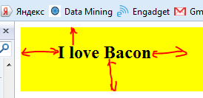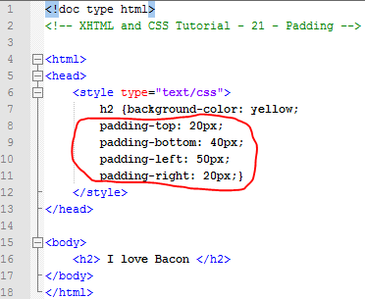

# 22. XHTML and CSS Tutorial - 22 - Border

To change the whole style (all sides) of the border we need to assign 3 (three properties): **color, width, and style.**

<style type="text/css">

h2 {

background-color: yellow;

padding: 15px;

border-color: red;

border-width: 3px;

border-style: dashed;

}

</style>

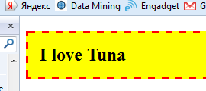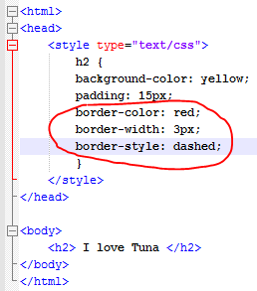

If we want to change a particular side(s) of the border then we need to specify this side:

<style type="text/css">

h2 {

background-color: yellow;

padding: 15px;

border-top-color: green;

border-top-width: 4px;

border-top-style: dotted;

border-bottom-color: red;

border-bottom-width: 3px;

border-bottom-style: dashed;

border-left-color: blue;

border-left-width: 6px;

border-left-style: dashed;

}

</style>

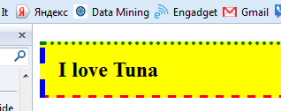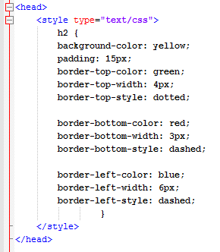

# 23. XHTML and CSS Tutorial - 23 - Margin

Assigning a **distance between paragraphs** (or other text properties)

<style type="text/css">

p {background-color: orange;

margin: 50px;

}

</style>

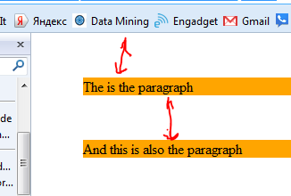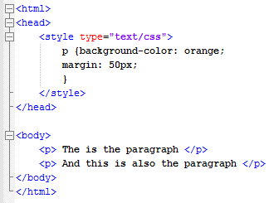

Or we can change each side of the margin individually:

<style type="text/css">

p {background-color: orange;

margin-top: 10px;

margin-left: 30px;

margin-right: 770px;

}

</style>

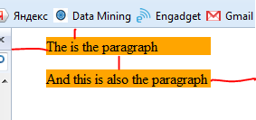 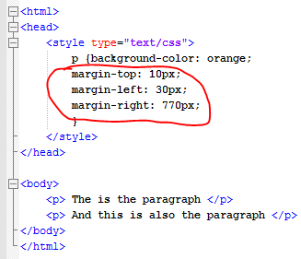

# 24. XHTML and CSS Tutorial - 24 - Width & Height

<style type="text/css">

h4 {background-color: red;

color:white;

width: 250px;

height: 150px}

</style>

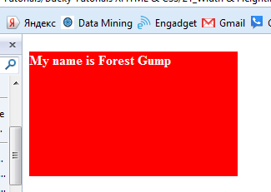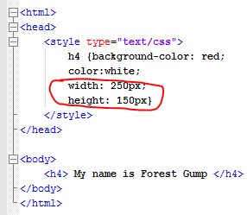

A shortcut for all the properties (instead of describing each individual property for a border)

<head>

<style type="text/css">

h4 {background-color: red;

color:white;

width: 250px;

height: 150px;

**border: 3px solid black;}**

</style>

</head>

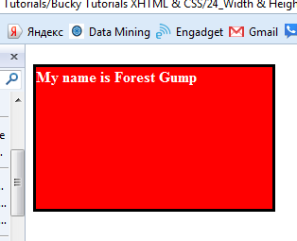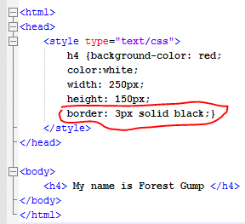

# 25. XHTML and CSS Tutorial - 25 - Styling Links

Creating different properties for the link depending on its status.

guys, bucky forgot to mention that the order he made the states;

* a:link
* a:visited
* a:hover
* a:active

is important for them to work properly, so when you﻿ try this out make sure that they're in that order

<style type="text/css">

a:link {color: red; text-decoration: none;}

a:visited {color: green;}

a:hover {

background-color: blue;

color: yellow;

text-decoration: underline;

font-weight: bold;}

a:active {background-color: orange}

</style>

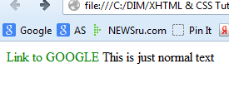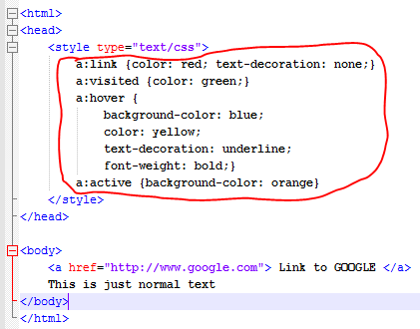

# 26. XHTML and CSS Tutorial - 26 - Styling Tables

<style type="text/css">

table {border: 3px solid blue;}

tr {background-color: yellow;}

td {border: 2px dashed red;}

</style>

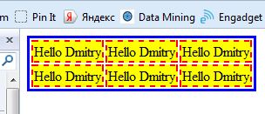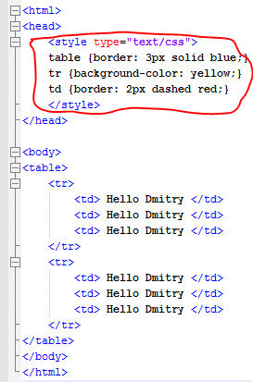

# 27. XHTML and CSS Tutorial - 27 - Background Images

Changing the style of the bullet points

<style type="text/css">

ul {list-style-type: circle;}

</style>

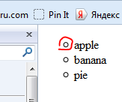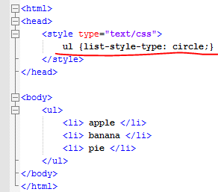

(2) You need to upload a picture to the folder first

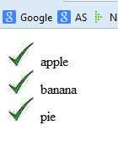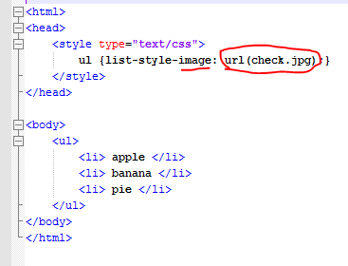

(3)

Assigning a border,

deleting bullet points marker

and removing left padding

<style type="text/css">

ul {border: 1px solid red;

list-style-type: none;

padding: 0;}

</style>

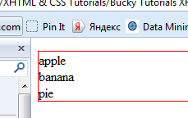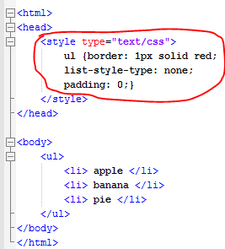

# 28. XHTML and CSS Tutorial - 28 - Style More Than One Elements & Span!

Applying **the same style for several different elements**. For example, for header and paragraph.

<style type="text/css">

h1, p {color: red;}

</style>

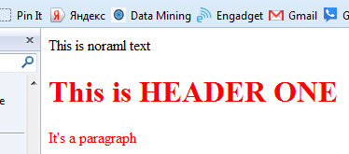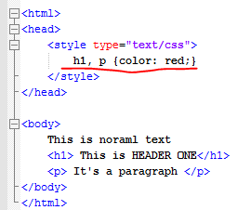

**<span>** tag allows to assign attributes to a part of the text not to the whole element.

<style type="text/css">

span {font-weight:bold;

color: red;}

</style>

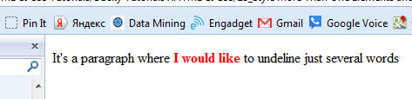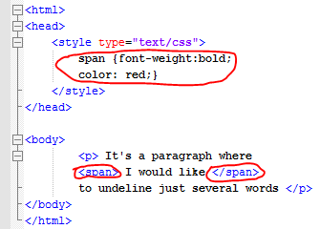

# 29. XHTML and CSS Tutorial - 29 - div

**<div>** -- allows you define sections on the webpage to place elements exactly where you want them to be.

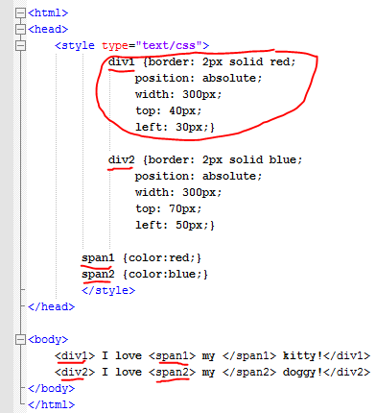

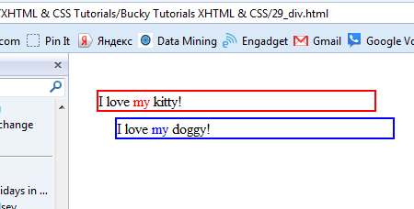

# 30. XHTML and CSS Tutorial - 30 - Styling Using Classes

Creating different classes by using “.” and the name of the class.

Attributes assigned to this class will be executed for all elements using this class.

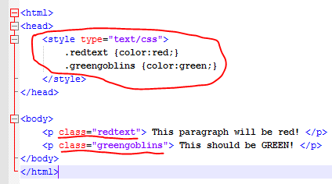

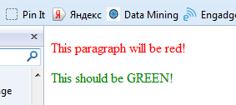

# 31. XHTML and CSS Tutorial - 31 - ID's

To differentiate <div> we need to assign different ID’s to different <div>

In order to do that we need to use the “#” sign and then write the name of the ID.

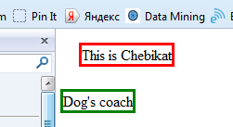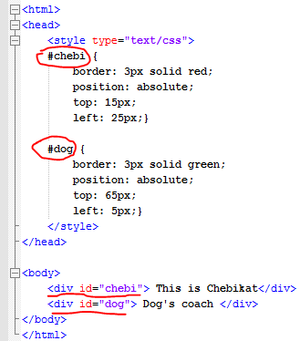

# 32. XHTML and CSS Tutorial - 32 - Child Selectors

If we want to style the link just only those that are inside of paragraphs (p) we need to tell CSS that **p is a parent and a is a child**. And how to style a child inside of a parent.

So, when CSS will go through all links it will style only links that are inside <p>

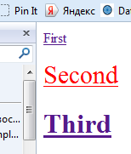 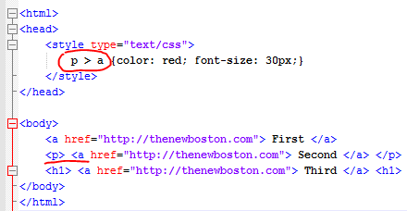

# 33. XHTML and CSS Tutorial - 33 - Pseudo Elements

It could be just a **part of another element.**

Let’s say we would like to style the first letter of each paragraph

Pseudo Elements are built-in, so we need to know them in order to use.

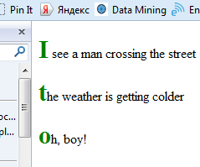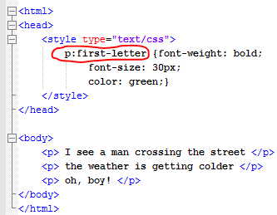

# 34. XHTML and CSS Tutorial - 34 - External Style Sheets

Applying one style to several pages.

We need to create a separate file (.css) where we describe attributes of all elements

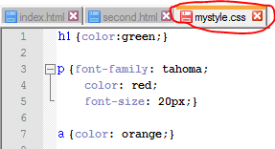

Inserting the reference to the .css file to the first page using the <link> tag

<link rel="stylesheet" type="text/css" href="mystyle.css"/>

rel="stylesheet" type="text/css" always stay the same

in href="mystyle.css" we need to mention the name of the file with .css formatting.

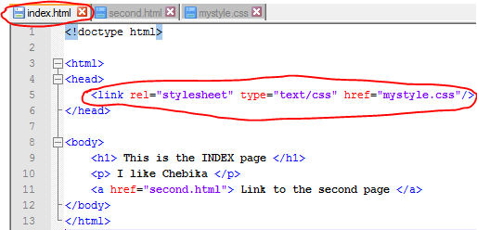

And inserting the same reference to the .css file to the second page

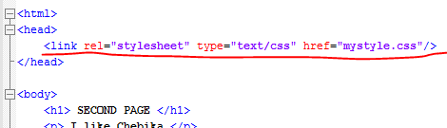

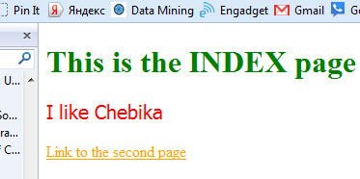

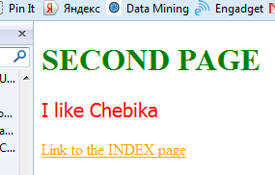

# 35. XHTML and CSS Tutorial - 35 - Overriding Styles

If we want to customize style on a particular sheet we need to override rules.

The last rule in order will be implemented to this sheet (as a cascade)

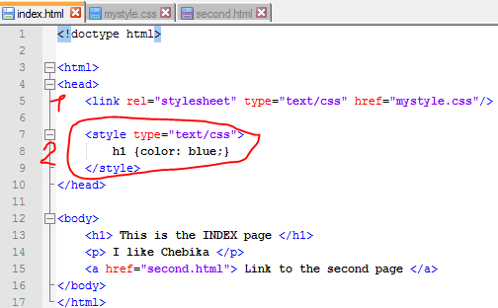

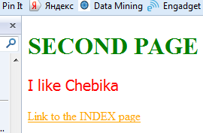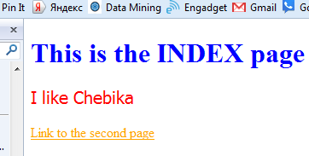

# 36. XHTML and CSS Tutorial - 36 - Absolute Positioning

We can **put boxes exactly** where we would like them to be.

<!doctype html>

<html>

<head>

    <style type="text/css">

        #apples {border: 2px solid red;

            position: absolute;

            width: 150px;

            height: 175px;

            top: 40px;

            left: 115px;}

        #blueberry {border: 2px solid blue;

            position: absolute;

            width: 150px;

            height: 175px;

            top: 30px;

            left: 15px;}

    </style>

</head>

<body>

    <div id="apples"> This is APPLE box </div>

    <div id="blueberry"> This is BLUEBERRY box </div>

</body>

</html>

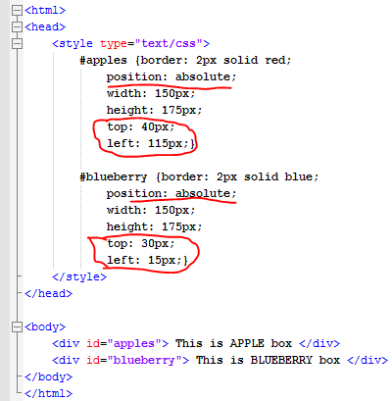

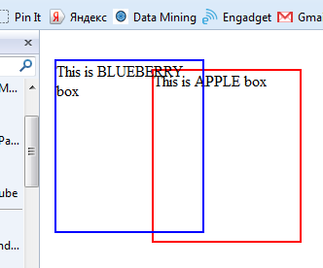

# 37. XHTML and CSS Tutorial - 37 - Relative Positioning

With **absolute** positioning it takes the First, Second, and Forth paragraphs and positions them in order. So, the Third paragraph will be positioned from **the top-left corner**.

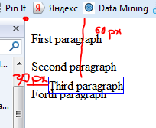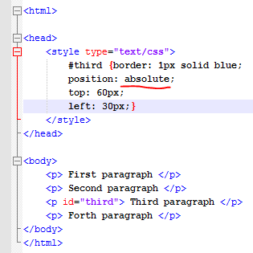

In case the positioning is **RELATIVE** it will count 60px down and 30px left from the position where the third paragraph **SHOULD HAVE BEEN LOCATED** if there were NO CSS RULES.

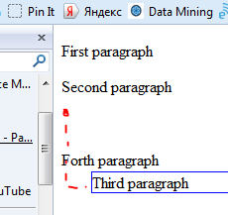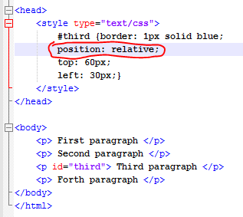

# 38. XHTML and CSS Tutorial - 38 - Fixed Positioning

With **fixed positioning** the element stays at the same place on the website and **it doesn’t move when you scroll the screen.**

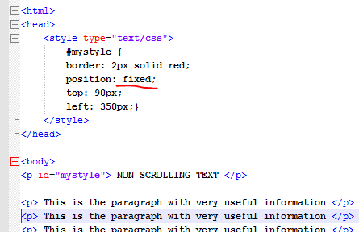

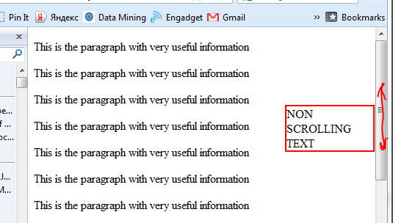

# 39. XHTML and CSS Tutorial - 39 - Max Width & Height

How to **automatically set the maximum Height and Width for images**.

For example, you allow to upload pictures on your website. All sizes will be different. So, to customize it and to have one formal size.

**We can use it with all elements. Not just with images.**

<html>

<head>

<style type="text/css">

img {max-height:100px; max-width:150px;}

</style>

</head>

<body>

<img src="Dima.jpg"> </img>

<img src="Natasha.jpg"> </img>

<img src="vvo.jpg"> </img>

</body>

</html>

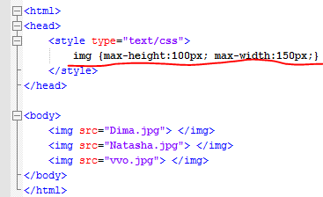

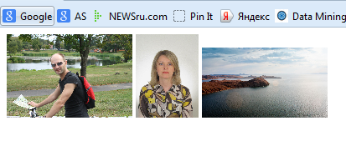

# 40. XHTML and CSS Tutorial - 40 - Introduction to Forms

<html>

<head>

<style type="text/css">

</style>

</head>

<body>

<form>

Enter Your Name HERE: <input type="text" name="username" size="35" maxlength="5" value="Dmitry by DEFAULT" /> </form>

</body>

</html>

Form type: input form

Enter Your Name HERE: asking you for the action

type: variable type

name: variable name

size: visible size of the input box (how it looks on the screen) but it doesn’t limit the number of characters you can input

maxlength: limit the maximum number of characters to be input into this field.

Value: value by default that will be assigned to the variable “username”

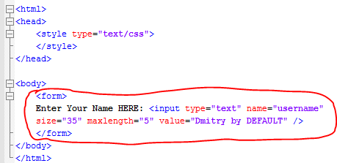

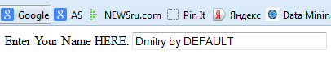

# 41. XHTML and CSS Tutorial - 41 - Check Boxes & Radio Buttons

<html>

<head>

<style type="text/css">

</style>

</head>

<body>

<form>

Enter Your Name HERE: <input type="text" name="username"

size="35" maxlength="5" value="Dmitry by DEFAULT" />

<br/>

Male: <input type="radio" name="sex" value="male" />

Female: <input type="radio" name="sex" value="female" />

<br/>

<p> Select the foods that you would like to order! </p>

Bacon <input type="checkbox" name="food" value="bacon" />

Ham <input type="checkbox" name="food" value="ham" />

Tuna <input type="checkbox" name="food" value="tuna" />

Soda Pop <input type="checkbox" name="food" value="soda" />

</form>

</body>

</html>

Name is actually a variable that will get a value (if selected). And the value it will get will be the assigned “value”.

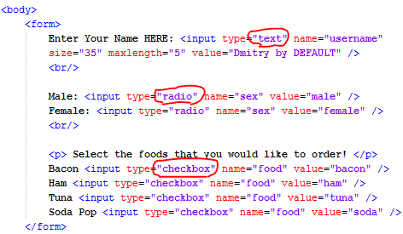

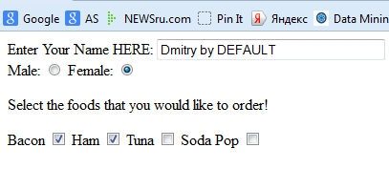

# 42. XHTML and CSS Tutorial - 42 - Drop Down Lists

Creating a **drop down list**

<body>

    <h3> What would you like to do today? <h3>

    <br/>

        <form>

            <select name="activities">

                <option value="footbal"> play footbal </option>

                <option value="hair"> get haircut </option>

                <option value="prog"> learning programming </option>

                <option value="tv"> watch TV </option>

            </select>

        </form>

    </body>

**List name: activities**

**Value: value assigned to a variable selected**

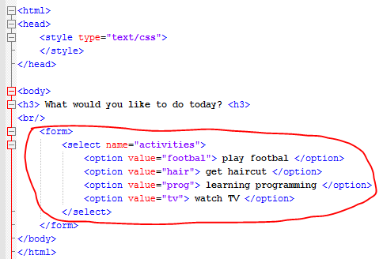

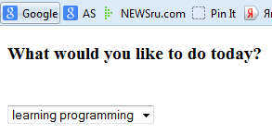

# 43. XHTML and CSS Tutorial - 43 - Text Areas

<body>

<h3> Tell me about yourself <h3>

<br/>

<form>

<textarea name="bio" rows="8" cols="40">

Type something here

</textarea>

</form>

</body>

</html>

By assigning values to “rows” and “cols” you are setting the initial shape of the text box as you want it to appear on the screen.

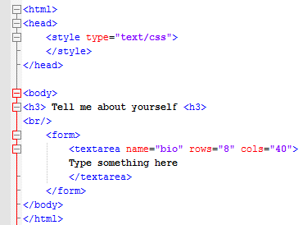

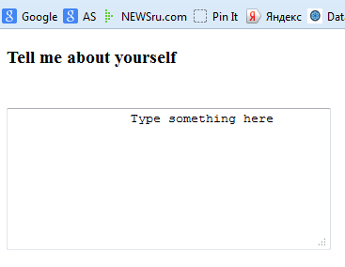

# 44. XHTML and CSS Tutorial - 44 - Passwords & Upload Buttons

<html>

<head>

<style type="text/css">

</style>

</head>

<body>

<br/>

<form>

Password: <input type="password" name="pword" />

<p> Submit a file </p>

<input type="file" name="dimfile" />

</form>

</body>

</html>

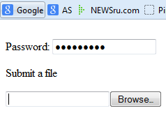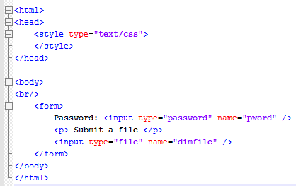

# 45. XHTML and CSS Tutorial - 45 - Submitting Forms

<body>

    <br/>

        <form action="executionfile" method="post">

            Username: <input type="text" name="uname" />

            <br/>

            Password: <input type="password" name="pass" />

            <br/>

            <input type="submit" value="Press Submit!" />

        </form>

    </body>

    </html>

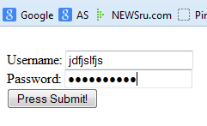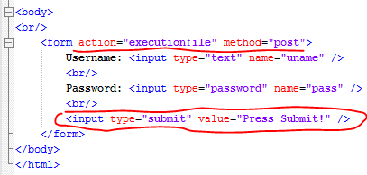

The tag <form> also has **action** and **method** attributes.

Action means that after a user presses the “submit” button it’s going to execute a file with the name “executionfile”.

**GET** = It sends﻿ the information and displays it in your address bar

**POST** = It sends the information and DOESN'T display it in your address bar

# 46. XHTML and CSS Tutorial - 46 - How to Publish Your Website!

Putting files on the web server so everyone has access to them.

**Uploading file using FTP (file transfer protocol)**

To the folder **public_html** on the server

1. One file (usually the main page) has to have the name “index.html”.

The system will always look for the “index” file.

1. Go to the the hosting web page

Click “FILE MANAGER “

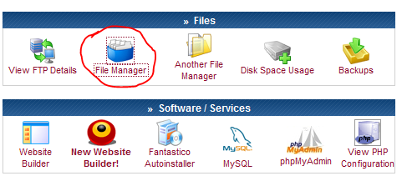

We have to upload all our files to the “public_html” folder

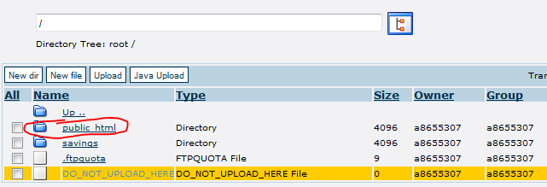

**Go there and click the UPLOAD button**

